Module 4 – Written Report

Python City Schools

Shannon Landis

January 2024

This analysis compares statistics for 15 schools. The school data consists of school types and school budget. Student data consists of student names and gender with scores for math and reading and student grade level. There were 39,170 total students in this data set across all schools with a total budget of $24,649,428.

The average math scores for all students was 78.99 and the average reading score was 81.88. 74.98% of students passed math while 85.81% passed reading. 65.17% of all students passed both math and reading. A pass rating being a score of 70 or above.



There are 2 types of schools included in this data: District and Charter schools. Student body sizes range from as few as 427 students to as many as 4,976 students. Budgets per student range from $581 to $652. There does not appear to be a correlation to budget per student and overall passing rate. Schools with the lower budget per student outperformed their counterparts.

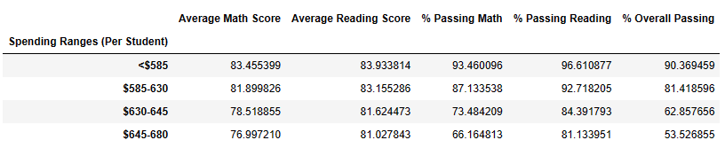

However, the school type appears to have the most impact with all charter schools outperforming the district schools. Every charter school had an overall passing rate of 89% or higher, while all district schools had overall passing rates below 55%.

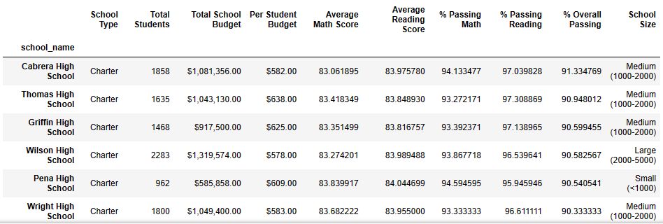

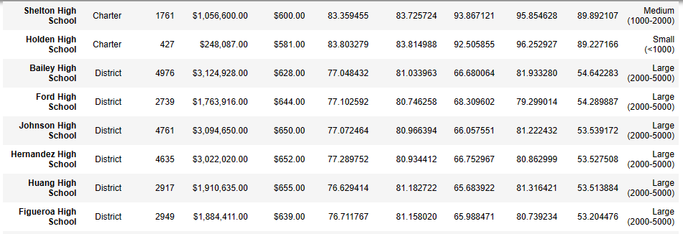



It seems that math scores hurt the district schools overall passing rate. District schools have less than 70% of students passing math with average math scores around 77%.

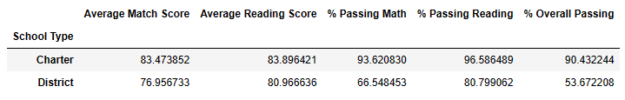

Also, the larger schools had the lowest percent of students passing math.

